Level 26 -> Level 27

The goal of this level is to get back to the /bin/bash shell and find the password for next level i.e. bandit27.

1. Minimize the terminal

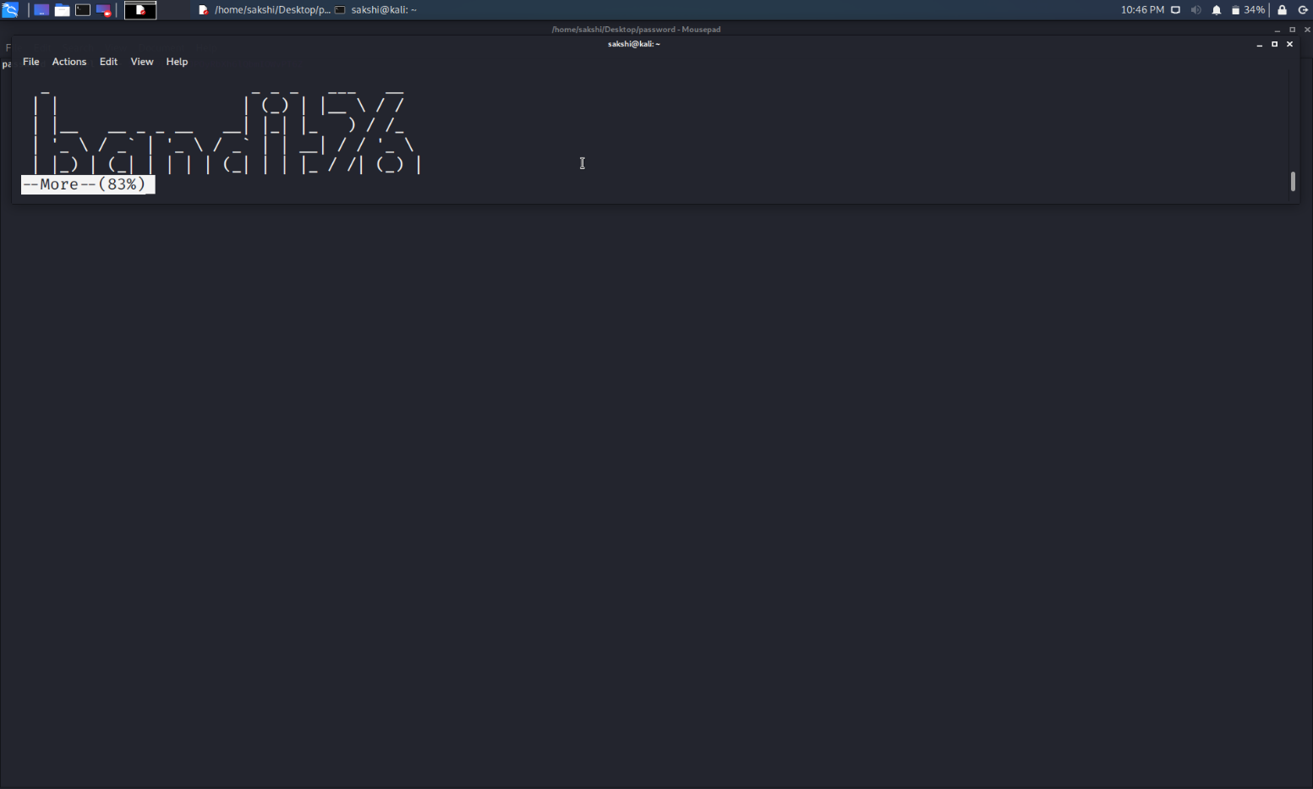

1. Write the command **:set shell=/bin/bash** to change the shell.

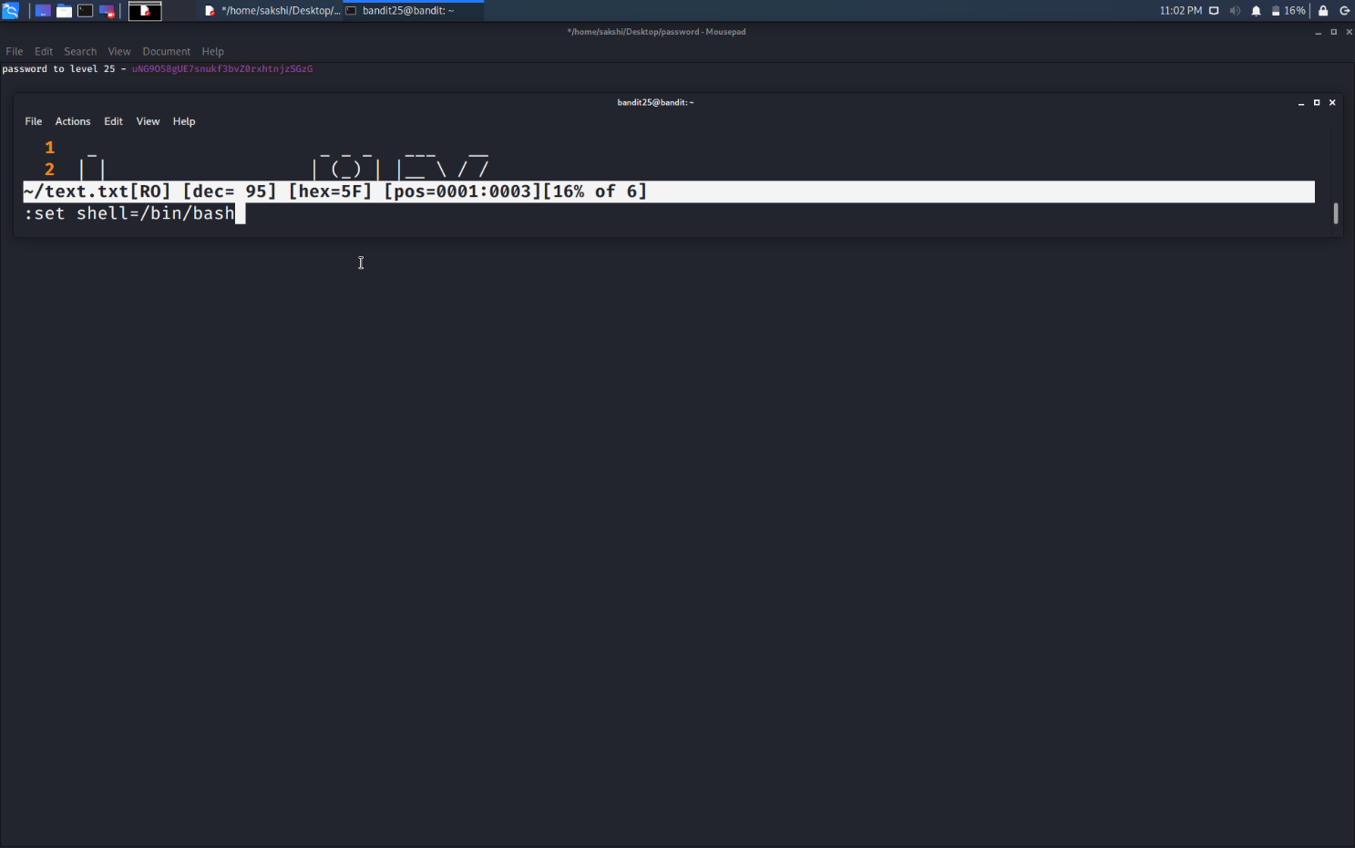

1. Now, write **:shell** to run the /bin/bash shell.

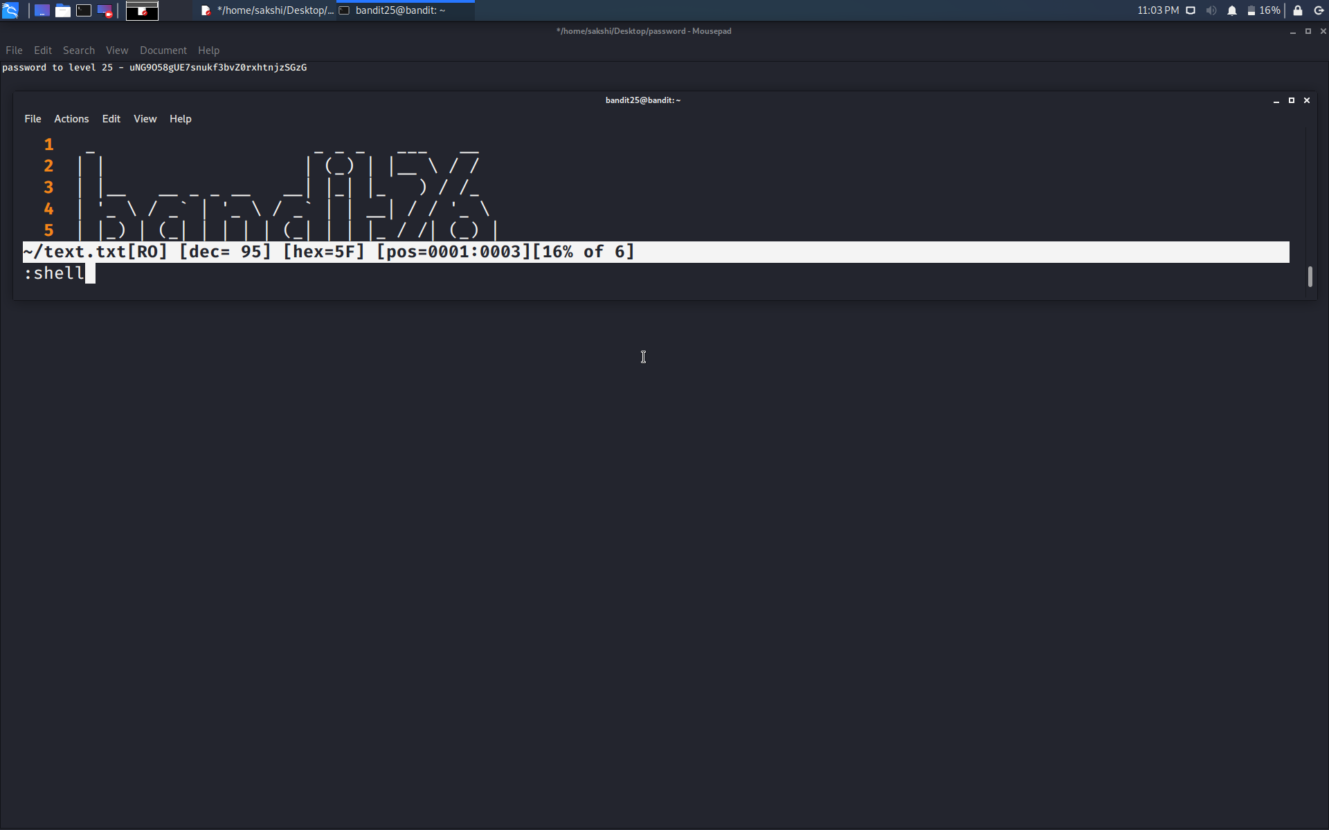

1. Now, use simple commands to get the password as done in one of the previous level.

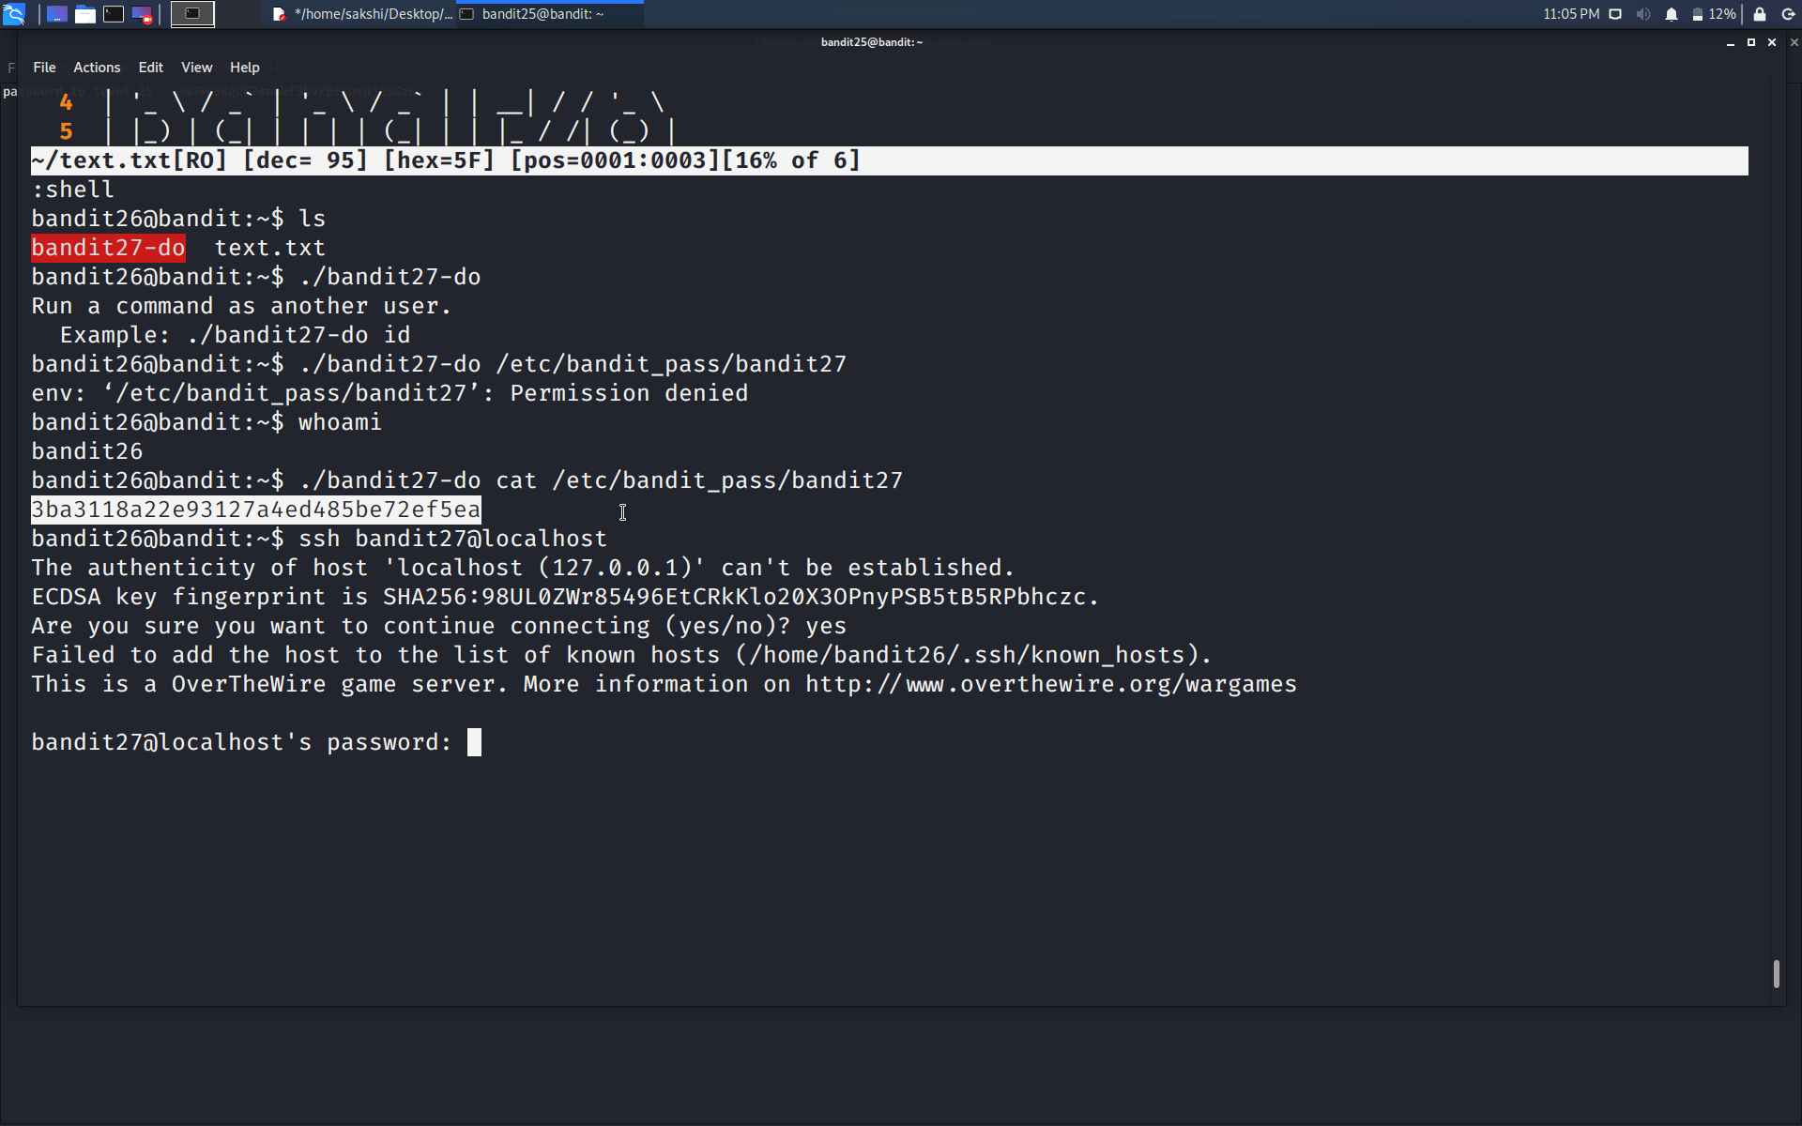

Use the command **ssh bandit27@localhost** to connect to the level 27.

Enter the password and hit enter.

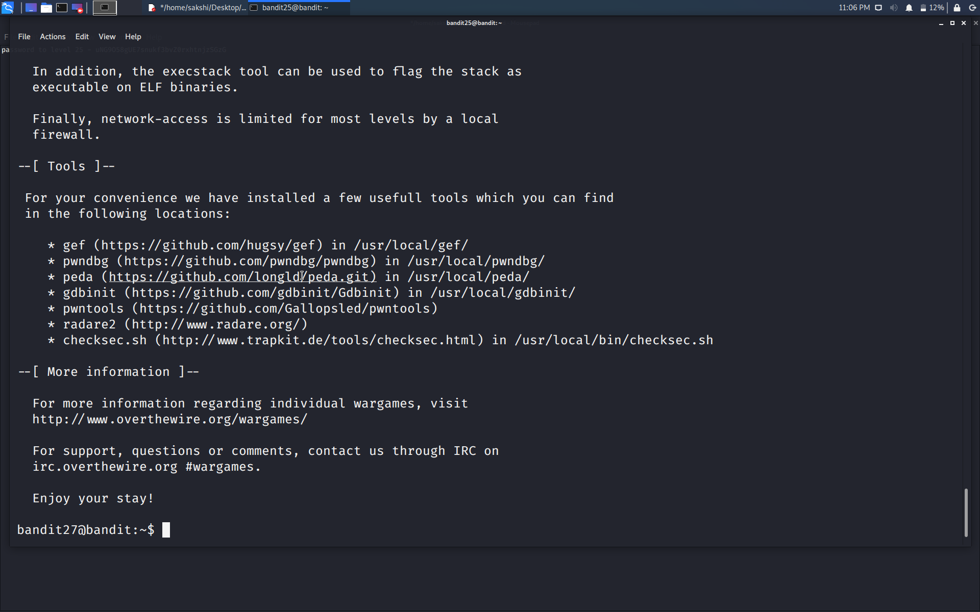

Successfully passed level 27.…